SEO Generated 360% More Organic Traffic for a NY Bankruptcy Firm

SEO

Results that speak for themselves

Key Stats & Results


360% Increase in organic traffic

Expanded reach of new client-specific locales across New York State

Behind the transformation

From Invisible to 360% Traffic Growth: SEO for a NY Bankruptcy Law Firm
An established New York bankruptcy law firm partnered with Rankings.io to rebuild its organic search strategy and expand its digital presence across one of the most competitive legal markets in the country. Through a focused SEO campaign, the firm achieved a 360% increase in organic traffic, secured top-3 Local Map Pack rankings, and dramatically expanded its visibility across Long Island and New York State, creating a scalable foundation for long-term client acquisition through organic search.

FROM CHALLANGES TO SUCCESS


The Challenge
When this established New York bankruptcy law firm partnered with Rankings.io, the objective was clear: Transform a strong offline reputation into dominant organic visibility across one of the most keyword-competitive legal markets in the state.
The firm had built decades of credibility serving clients across Long Island and the surrounding region. But translating that authority into digital growth had proven elusive. A previous SEO partner had failed to move the needle, and the firm's managing attorney knew it was time for a different approach.
Like many high-volume bankruptcy practices, the firm faced a set of familiar but compounding challenges:
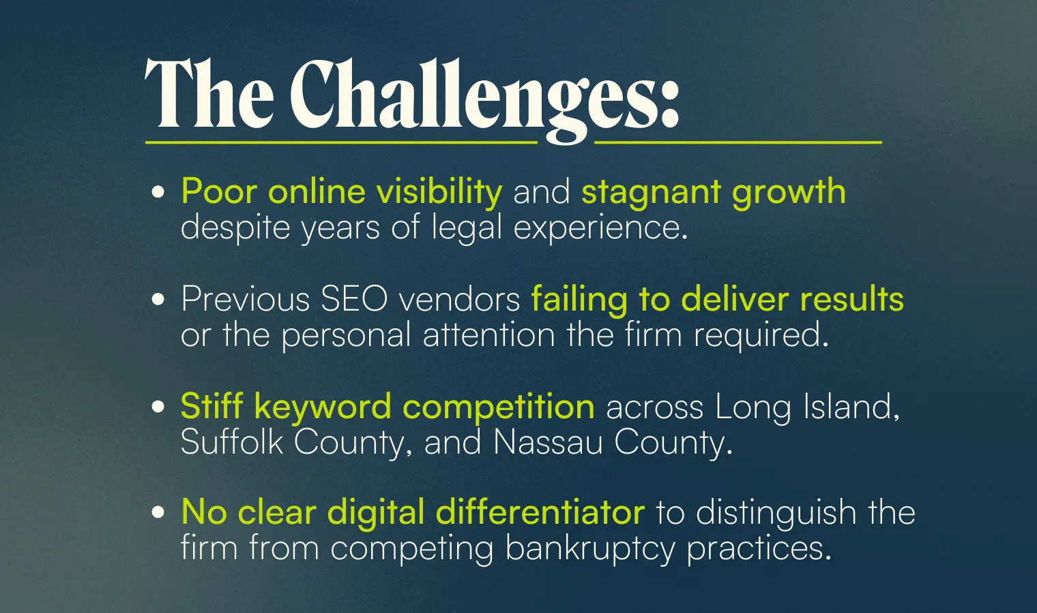



How We Did It: The Strategy
Rankings.io implemented a complete, full-service SEO strategy to build sustainable rankings in a competitive multi-county legal market. Rather than applying generic tactics, we tailored every element to the firm's specific geographic footprint and practice focus.

SEO Strategy for a New York Bankruptcy Law Firm
Our approach targeted the core ranking factors required to win across Long Island's densely contested local markets, with a deliberate expansion strategy to increase reach across New York State.

1. Complete Website Optimization
Rankings.io conducted comprehensive on-site optimizations of the firm's website, covering technical performance, site architecture, page-level content quality, and internal linking. This ensured that search engines could fully crawl, understand, and prioritize the firm's most valuable practice area pages.

2. Content Strategy & Blog Development
We assisted in the creation and ongoing ideation of high-quality blog content and service pages, establishing the firm as a credible, topically authoritative source for bankruptcy law questions across its target markets.

3. Geographic Location Page Expansion
We built dedicated location pages targeting not just the major nearby counties but a wide network of smaller communities within the firm's service area. This granular geographic strategy allowed the firm to rank in client-specific locales it had previously been invisible in, significantly expanding its digital footprint across Long Island and greater New York State.

4. Link Building & Scholarship Campaign
To build the domain authority required to compete for high-value keywords, Rankings.io developed a dual link-building strategy. We complemented standard outreach with a scholarship campaign that served two purposes: giving back to the local community the firm cared deeply about, while simultaneously earning highly authoritative backlinks from academic institutions.
The campaign attracted approximately 300 student entries annually and earned endorsements from 58 colleges and universities, resulting in 151 .edu backlinks, a key driver of the firm's improved domain authority and search rankings.

5. Social Media & Brand Building
Rankings.io managed the firm's social media presence and supported broader brand-building efforts, reinforcing its credibility and ensuring consistent messaging across channels.



Before & After
After executing a comprehensive SEO program, the firm achieved measurable, sustained growth across organic traffic, keyword rankings, and geographic reach.
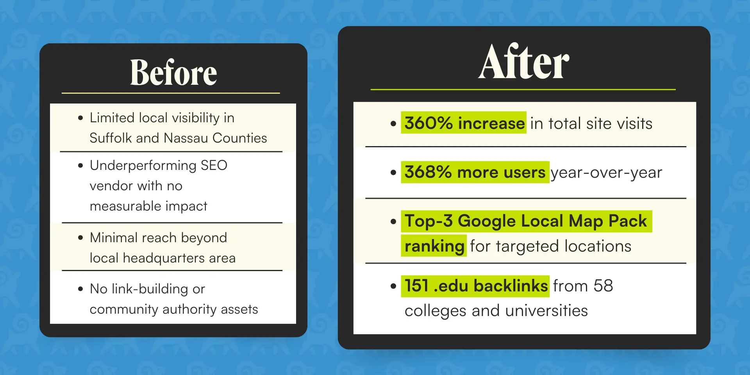

Key Wins
- Top-3 ranking in Google's Local Map Pack for primary geographic targets
- +360% total site visits and +368% total users year-over-year
- 287% increase in total pageviews year-over-year
- 194% rise in New York City-based traffic
- New York State visitors doubled: 9,836 → 20,100 (+104%) in a single year
- 151 .edu backlinks secured from 58 colleges and universities via scholarship campaign
- ~300 student entries annually, reinforcing both community authority and link equity

Ready to Grow Your Firm?
This case study demonstrates what a focused, full-service SEO strategy can achieve for bankruptcy law firms competing in dense metropolitan markets.
At Rankings.io, we specialize exclusively in SEO for lawyers, with dedicated expertise in bankruptcy law firm marketing.
Our proven approach to technical SEO, content authority, local targeting, and link building helps your firm rise through the rankings and stay there.

